PHASE 7 – INTEGRATION & EXTERNAL ACCESS
- Remote Site Settings
Remote Site Settings were configured to allow Salesforce to communicate with an external endpoint.
A dummy external URL was added
This enables secure outbound callouts from Salesforce
No real data exchange is performed
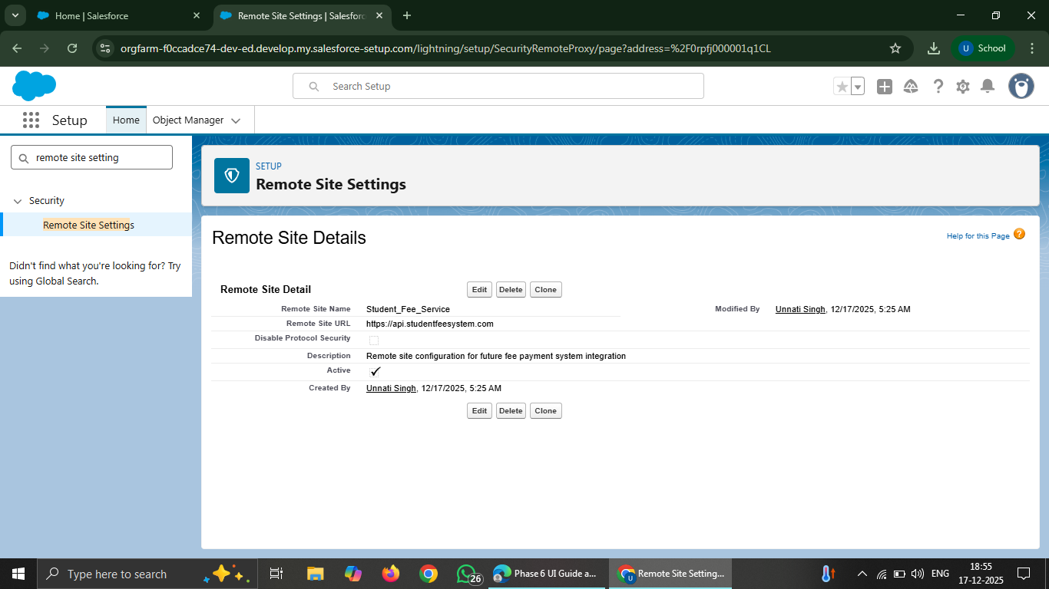

- Named Credentials & External Credentials
Named Credentials were configured along with External Credentials to manage integration details securely.
Endpoint URL is stored securely
No username or password is hardcoded
Authentication is kept as No Authentication for learning purpose
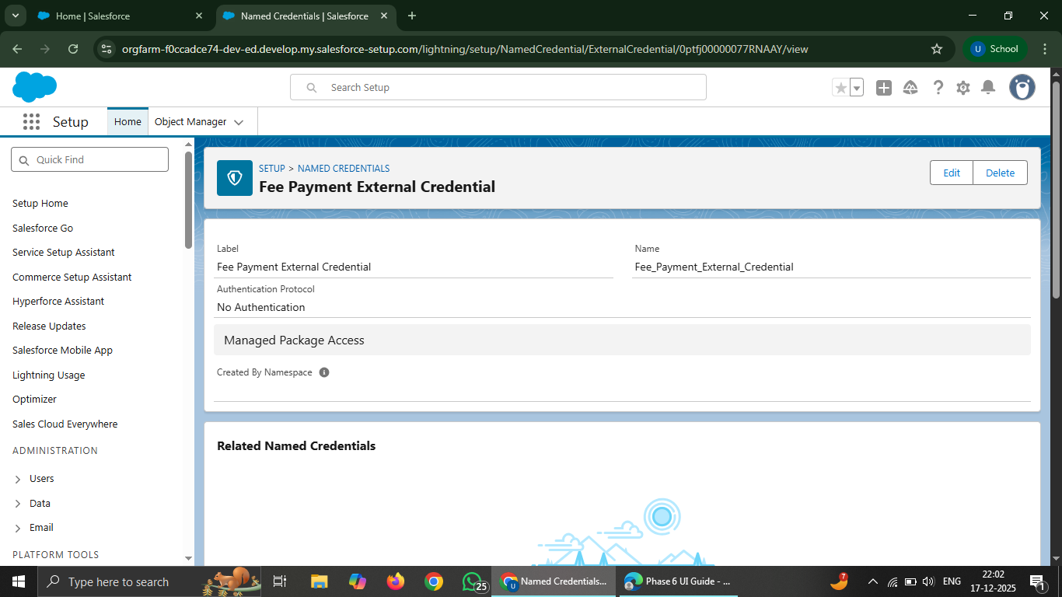
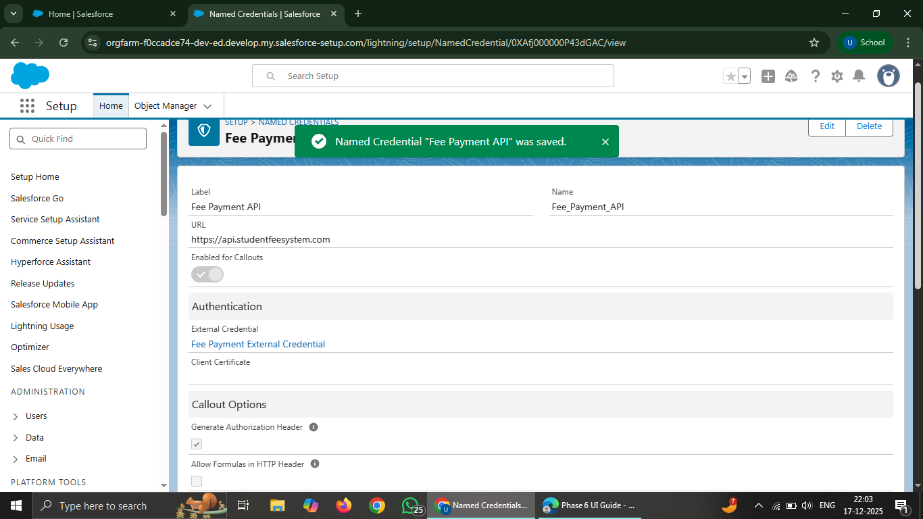

- Platform Events
A Platform Event was created to support event-driven integration.
Event is published when fee payment is completed
Event contains student ID and payment status
External systems can subscribe to this event in future

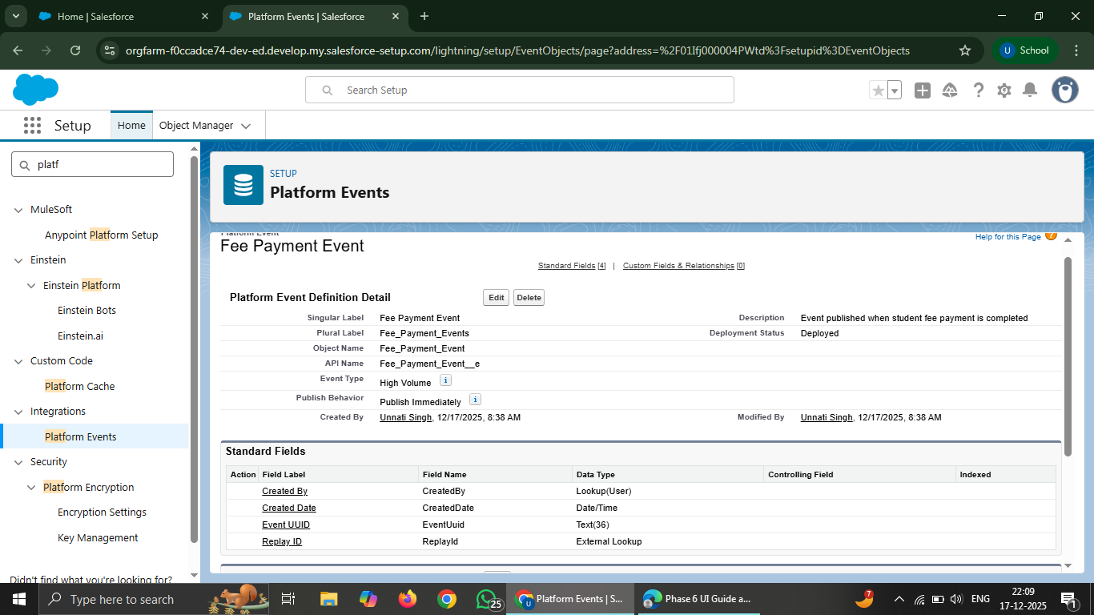

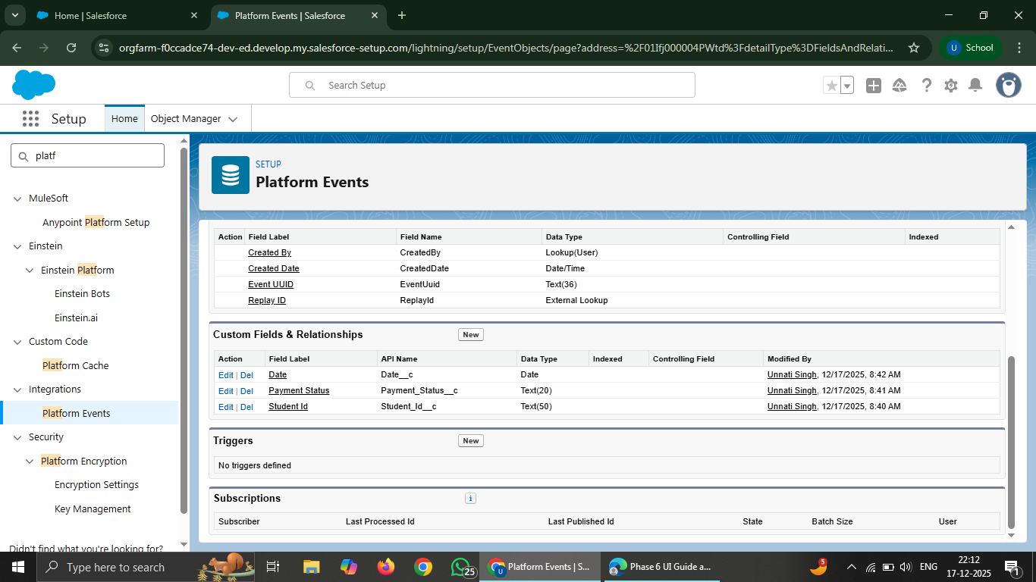

- Change Data Capture (CDC)
Change Data Capture was enabled on the Student object.
Any create, update, or delete on Student record can trigger events
External systems can receive real-time updates

